Acceleration of Events
October 26th, 2021

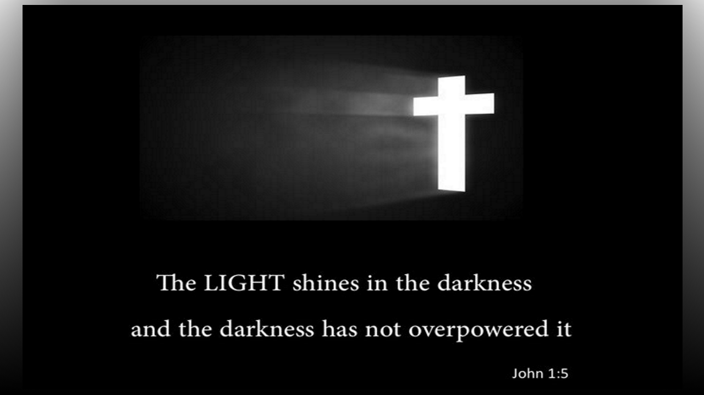
Dear Father, take us to the place where we no longer are looking at the mountains we face, but are looking down upon them with our heavenly eyes and ears and can clearly see and hear Your wisdom, guidance, truth and light. Amen.

Blessed Mother began speaking, “If you only knew how little time you all have left, you would be spending your time wisely, not caught up in trivial matters that are not contributing to the salvation of souls. Just then, I noticed tears of blood streaming down her face on the Mother of Mercy painting. She continued, “Cataclysmic events are accelerating around the world and your focus needs to be on the souls who will perish today and do not know My Son. When disasters strike, my children will be able to not only provide practical help like in the dream, but also provide comfort to those who mourn.”

Here, Mother Mary is referring to a dream where everyone on the refuge was helping a family in town rebuild their home so it would once again be habitable.

Blessed Mother continued, “The wise among you will know when danger approaches and will conceal themselves in the Lord’s loving mercy. You dear child will experience a suffering shortly that when you, with Our help, overcome it, will bear the most wonderful fruit. This is a grace My Son will give you, you need only to cooperate with it because it will not seem like a grace at the time.

“My children value eternal life over your possessions. You were brought into the world with nothing and neither can you carry anything out. You need to be willing to abandon all….your houses, your vehicles, your lifestyles, your investments to escape disasters and when your Lord is calling you to follow Him. Every one of you has a mission to fulfill on earth and it is time for you to take it seriously. Please dear ones, remember that your soul is more important than any material things, take nothing for the journey.

“God always does what is right and He will judge all the earth according to what is just in His eyes. Few of you give any thought to prepare for His judgment and this will be the ultimate examination that you will face, to give an account to Him for your lives. You all know He loves you and what is expected from you. If you feel abandoned, it is because you have not obeyed. Obedience is key. Ask for this grace and add it to your armor daily and stay secure in your cloaks of faith. It is by His grace and through faith that you are saved.

“Precious ones, no matter what may happen around you, God is your faithful and reliable source of strength. Homes consecrated to the Sacred Hearts are and will be protected if you live there in accordance with Divine Will. He has empathy for you and feels for you when you suffer. In times of distress, humble yourselves before Him and throw all your anxiety on Him because He cares for you and has deep concern for all of you. Your Lord loves you so and desires none would perish, but have life eternal. Now is the time for all good Christians to come to the aid of their nation and the world. My children, please stay under my maternal mantle.” Then I saw all of us as if we were baby chicks underneath the protection of our merciful and powerful Mother hen.

